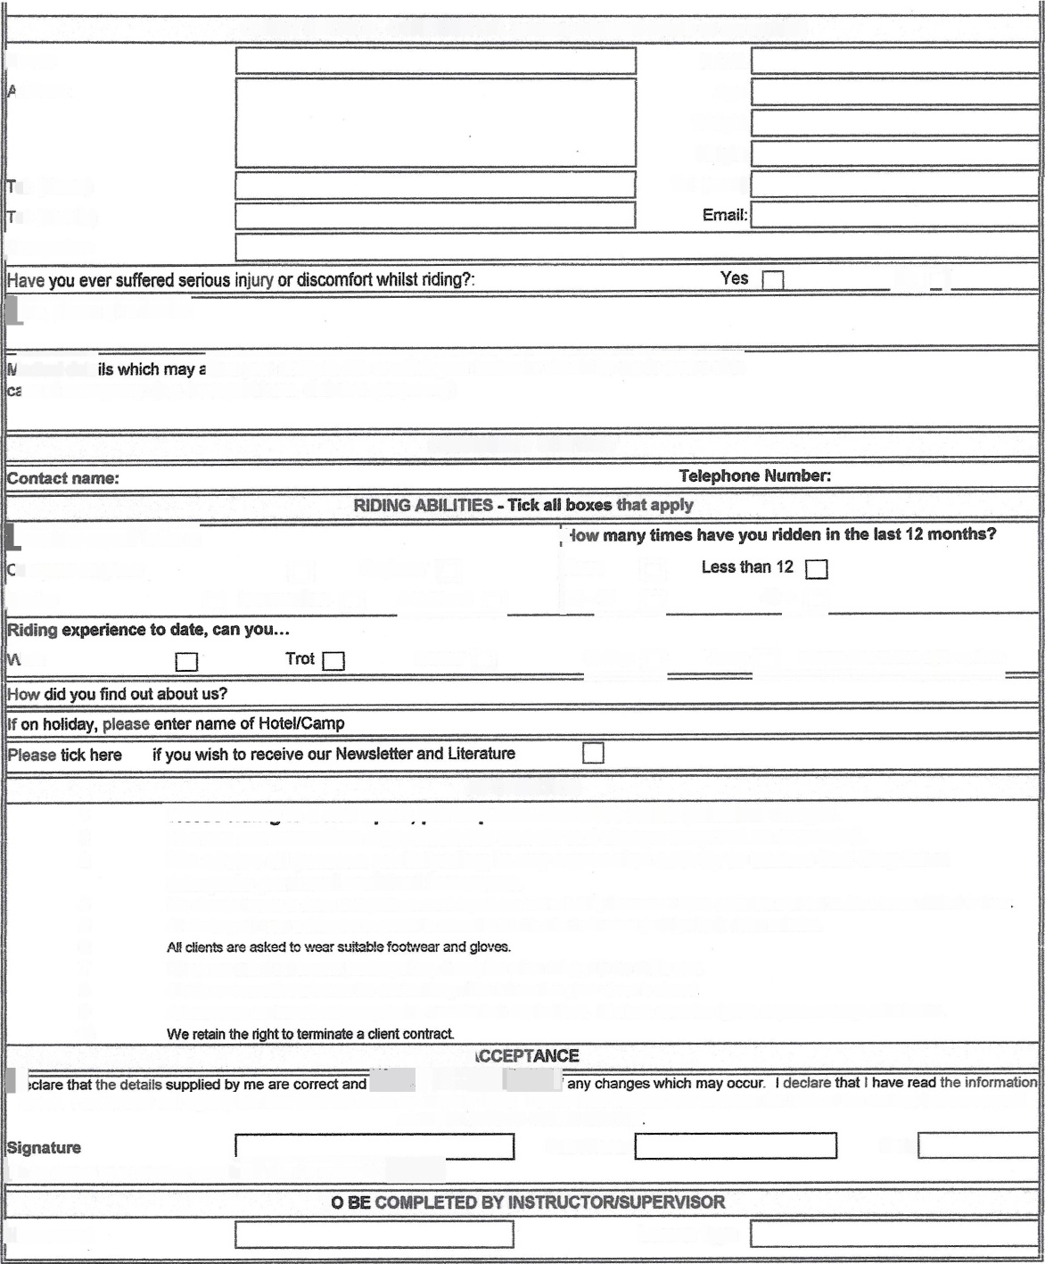
CLIENT DETAILS - CONFIDENTIAL (please complete boxes as apropriate)
ENamel
D.O.B.
.ddress:
Age:
Weight:
Height:
Tel: (work)
el: (Home)
el: (Mobile)
joccupation:
no 1
dyes, please give details:
maffect your abiHty to ride or which your Instructor should be made aware of h lse of emergency: (e.g. back problems, diabetes, pregnancy)
EMERGENCY CONTACT
Id©nsider myself to be a:
e
bmplete beginner
U Beginner []
iNane U
[12-40 []
40+ []
[Novice
a Intermediate []
Advanced [-1
Falk
Canter []
hI
GaUop []
Jump [] pease tick where apwopriate
INFORMATION
1
2
3
4
5
6
7
8
9
10
r ore holds potential danger.
Horses are sometime unpredictable and do not always respond as expected.
We advise all persons participating in any equestrian activity to ensure that they have adequate personal accident insurance.
We alocate hors® to riders takjng into account experience and suitability however all riders retain the right not to ride a horse allotted to them AH clients must wear a riding hat approved to current B.S.L Standard whenever participating in riding ac#vile&
Clents are asked not to wmr jwellery of any descriptbn when riding or in the stable area.
CHeats are requested to inform the statSee tf any of the information given above is altered.
AH in$&uaton are trained and competent to teach to their dda led level. AH clients retain the right to request a change of instructor.
E
Fi@aiRfi@}@©1
above_ I understand that signing this form does not affect my statutory rights. t understand that this form becomes the basis of the oontract between myself
and BRIDLEWOOD RIDING CENTRE
Print Name
Date
kTo be signed by a parent or guardian if c+tent is under 18 y@
O
horse used
Lesson Type
EXCEL\BRIDLEWOOD\FORM$\twwrawclientncord

